**PCRs**

*cyt-b* (Dufresnes et al 2013)

Hyla-L0: ATGGCCCCTGTTTTACGCAA

Hyla-H1046: TAAATGGGTCTTCTACTGG

Amplifications were carried out in 25µl containing 2.5µl of Qiagen PCR buffer (with 1.5mM of MgCl2), 0.5µl of dNTPs (10mM), 1.5µl of each primer (10µM), 0.1µl of Qiagen Taq (5 units/µl), and 1µl of DNA (10ng/µl). PCR conditions were as follow: initial denaturation at 94°C for 1’; 38 cycles of 94°C for 30” (denaturation), 48°C for 1’ (annealing), 72°C for 1’ (elongation); and final elongation at 72°C for 10’.

*rag-1-Duf* (Dufresnes et al 2013)

Ha-Rag1f: ATGCCCTGAGAAATGCAGAG

Ha-Rag1r: TTTCGTAGCGTTGCAAGTTC

PCR templates (25 µl) contained 2.5µl of Qiagen PCR buffer (with 1.5mM of MgCl2), 0.475µl of dNTPs (10mM), 1.25µl of each primer (10µM), 0.125µl of Qiagen Taq (5 units/µl) and 2µl of DNA (10ng/µl). We used similar PCR conditions as for *cyt b* expect for the annealing temperature (54°C) and final elongation time (5’).

Stöck et al (2008) published slightly different primers for the same gene, which produces a larger amplicon. As this contains more SNPs, it would be good to get this to work, or perhaps a combination of the forward and reverse primers from the two studies.

*rag-1-Stoeck (Stöck et al 2008)*

MARTFL1-Stoeck: AGCTGGAGYCARTAYCAYAARATG

RAGIF-Stoeck: CCAATGTCGCAGTGCAARGCRTC

Note, annealing temp in Stöck et al (2008) used touch down 60–45 (15 cycles) + 45 (38 cycles). I would rather not have to use this, so we could use the same PCR protocol as for the Dufresnes et al *rag-1* amplification. But if it is easy enough to try it then perhaps we can make a test if the other reactions do not work so well.

**Samples**

For PCR testing we need to try samples from both pure species and ideally also a population in the hybrid zone. So **for the tests I would suggest sites 1 (PIA), 6 (LDC) and 12 (ROS), perhaps two or three samples from each.**

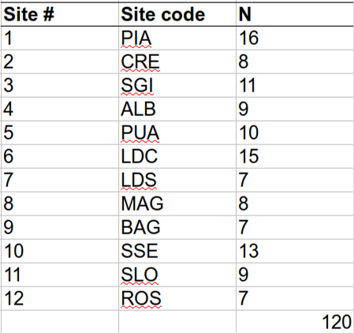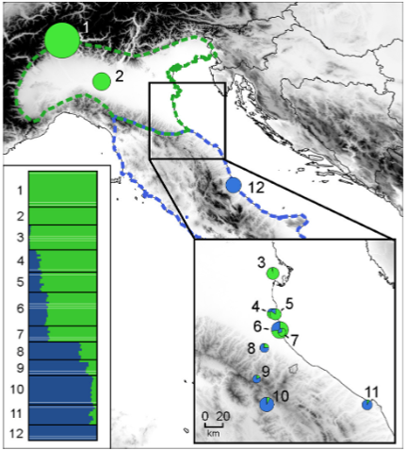

**References**

Dufresnes, C., Wassef, J., Ghali, K., Brelsford, A., Stöck, M., Lymberakis, P., et al. (2013). Conservation phylogeography: does historical diversity contribute to regional vulnerability in European tree frogs (Hyla arborea)? *Mol. Ecol.* 22, 5669–5684.

Stöck, M., Dubey, S., Klütsch, C., Litvinchuk, S. N., Scheidt, U., and Perrin, N. (2008). Mitochondrial and nuclear phylogeny of circum-Mediterranean tree frogs from the Hyla arborea group. *Mol. Phylogenet. Evol.* 49, 1019–1024.